**FdSc / Cert HE Computing**

**WKL200 - Work Based Learning**

**Planning & Development of Website for D&COV Connect Ltd.**

**Students Name:**

**Students ID:**

**Module Coordinator:**

**Deadline: 03/10/2025**

Contents

**1. Introduction:** 2

**2. Project Planning:** 3

**3. Project Design:** 4

**4. Project Development:** 5

**4.1 HTML: Structure and Content** 5

**4.2 CSS: Styling Using Bootstrap, DaisyUI, and Shadcn/UI** 6

**4.3 JavaScript: Interactivity** 6

**4.4 Workflow Steps** 6

**4.5 Deployment using GitHub Pages** 7

**5. Evaluation and Reflection** 7

**5.1 Achievements** 7

**5.2 Challenges Faced** 8

**5.3 Challenge Solutions** 8

**5.4 Future Development** 8

**6. Conclusion:** 8

**7. References:** 10

# **1. Introduction:**

D&COV Connect Ltd is a private limited company in the UK founded in September 2023 and dealing in removals and relocation services. The company provides a range of services, namely house moving, office moving, packing, storage, and man & van services. These services are necessary to residential and business clients that require timely and trustworthy relocation help. In today's highly competitive business world, a firm digital presence is essential for service companies to attract and retain customers (Chaffey & Ellis-Chadwick, 2019).

The main goal for the project is to make an interactive, responsive, and user-friendly website for D&COV Connect Ltd to reflect the professionalism of the company and promote the accessibility of its services. The website is intended to be both an information site and a marketing vehicle through which potential clients could look at services available and make decisions. Further, through the use of digital technology, the project aids the company in marketing itself and improving its interactions with the clients (Laudon & Traver, 2021).

The web development process incorporates current technologies like HTML for structure, CSS with frameworks like Bootstrap, DaisyUI, and Shadcn/UI for responsive and stylistic presentation, and JavaScript for interactive behaviour. These technologies provide a seamless user experience on all devices and browsers, which is an important requirement in modern web design (Duckett, 2014).

This is a presentation of the phases of planning, designing, developing, testing, and implementing this project, followed by management methodology discussion, results, and observations for a complete insight into the project life cycle.

# **2. Project Planning:**

The planning stage was paramount in ensuring the website of D&COV Connect Ltd addressed both user and business requirements satisfactorily. The activity started with requirements gathering, which entailed examining the services the company had to offer and understanding the expectations of the prospective customers. Functional necessities encompassed a simple-to-browse organization, separate service pages for home moves, office moves, packing, storage, and man & van services, as well as a contact form for customers to make inquiries in a timely manner. These necessities follow web design best practices, where simplicity, ease of use, and functionality are key to user interaction (Krug, 2014). Aside from functional necessities, beauty and branding necessities were also given importance. The site had to project a professional image worthy of the company's values of trust and reliability. This ties in with research conducted by Nielsen (2020), where visual consistency and branding directly affect user trust and retention. Wireframes were created at this point to conceptualize the homepage structure, listings of services, and contact page in order to make an early assessment of layout and content allocation. Wireframing facilitated rapid decision-making and allowed for adjustments before the development phase (Garrett, 2011).

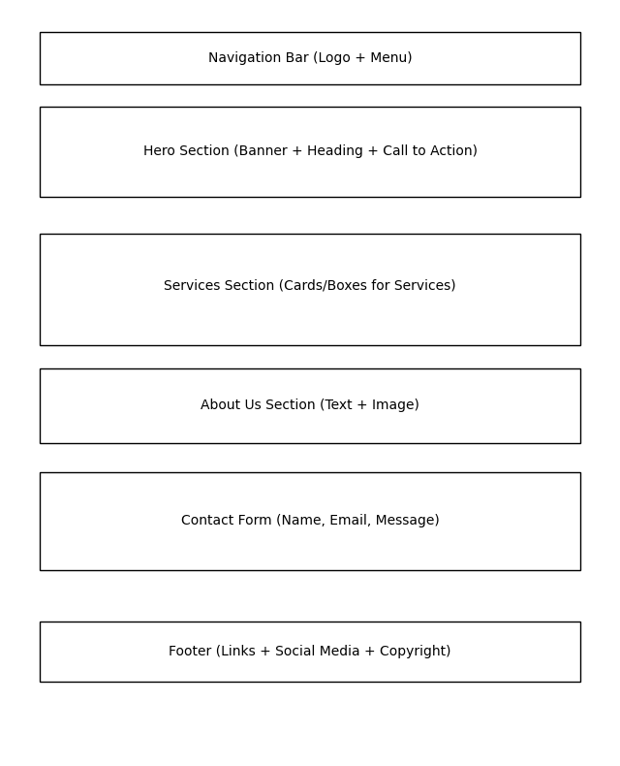

The project aims were threefold. One, to enhance the firm's presence online to easily find services by potential clients via a professional web presence. Two, to enable easy service booking information to users through simplifying the customer journey from query to booking. Three, to enable professional branding via a contemporary UI through responsive design to ensure accessibility across platforms. Attainment of these goals was anticipated to enhance both customer acquisition and satisfaction.

The planning schedule adhered to the four-week timeline on a phase-by-phase basis:

Week 1 (Planning & Design): Gathering requirements, wireframing, UI mock-ups.

Week 2–3 (Development): Structure coding with HTML, styling using CSS frameworks, and incorporating interactivity using JavaScript.

Week 4 (Testing & Deployment): Functional and responsive testing, compatibility checks in browsers, followed by deployment using GitHub Pages.

A Gantt chart was developed to map the timeline, showing task dependencies and ensuring that deliverables were accomplished in a systematic order. Gantt charts are widely accepted as useful project management tools that enhance task monitoring and accountability (Lock, 2020).

This structured planning helped to ensure that the project had a clear roadmap, coordinating technical execution against business goals and providing a foundation for successful implementation.

# **3. Project Design:**

The design phase of the D&COV Connect Ltd website focused on delivering a clean, modern, and responsive interface that communicates professionalism while ensuring ease of use. To achieve this, the project employed a combination of Bootstrap’s responsive grid system, DaisyUI’s semantic components, and Shadcn/UI’s modern React-style design principles. These platforms in total enabled the creation of a website that automatically adjusts on devices and browsers, something that is crucial since over 60% of traffic on the web comes from mobile devices (Statista, 2024).

UI/UX design decisions emphasized simplicity and legibility. Bootstrap was employed to apply an organized grid system, with content such as service descriptions, pictures, and navigation items being aligned consistently. DaisyUI elements provided semantic styling that was simple but retained readability, with Shadcn/UI providing a polished, contemporary look to interactive objects, in keeping with the company's professional profile.

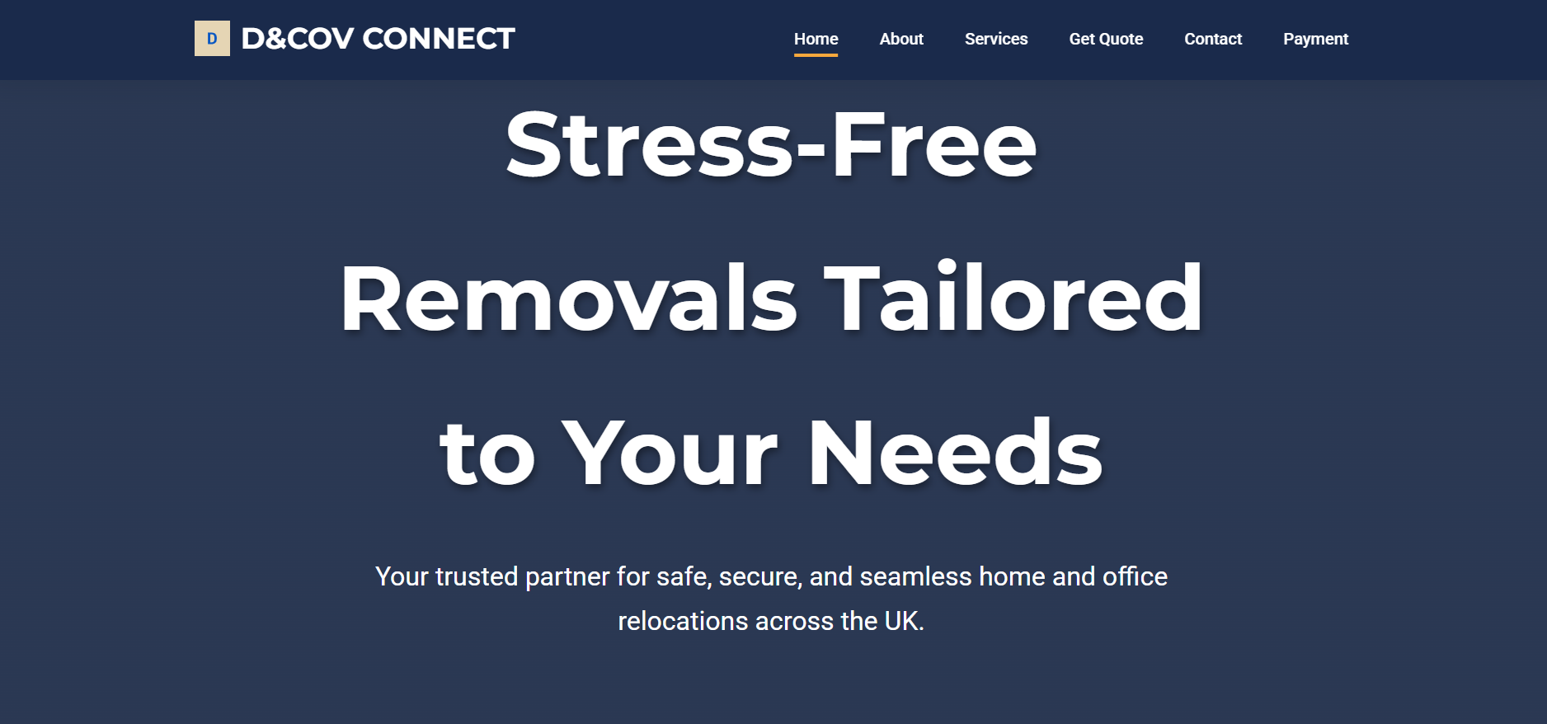

The colour palette prioritised neutral colours with highlights of blue, representing trust and reliability, which are two of the most important values in the removals industry. Typographic decisions were based on legibility, employing sans-serif fonts to preserve a clean, professional look. Decisions on layout were made to allow users to easily find details of services, with headers and call-to-action buttons placed strategically to guide users through.

Major elements were a navbar for easy navigation, service cards to promote services like home clears and self-storage options, and a contact form for instant communication. All the elements were selected to make the user's journey from browsing to enquiry faster.

By matching the design with client branding, the website not only conveys the trustworthiness of D&COV Connect but also places the company competitively in the online marketplace, making customers have a good first impression.

# **4. Project Development:**

Development phase of the D&COV Connect Ltd website was the most technically intensive part of the project, bringing design ideas into an operational digital platform. The process was done in a disciplined workflow, progressing through content setup, styling, interactivity, and deployment.

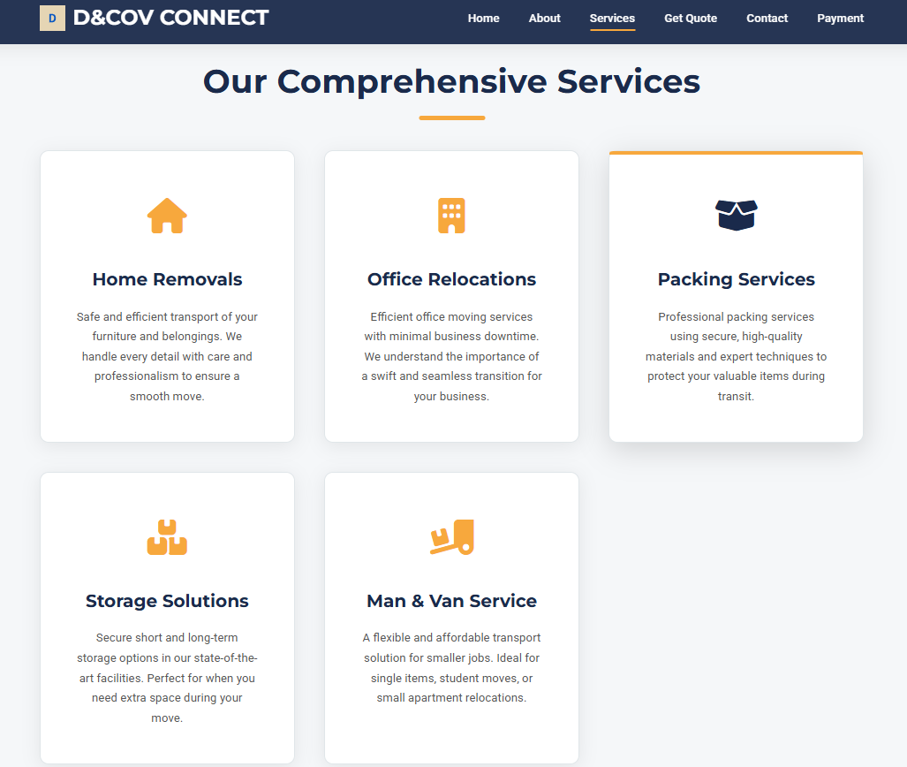

## **4.1 HTML: Structure and Content**

The process began with the creation of the HTML structure, providing the waterfall phasing of the site. Every page was developed using semantic elements such as <header>, <nav>, <section>, and <footer>, for accessibility in design along with clarity in code. The initial design of the home page featured an introduction to the company with emphasis on services and quick access to the essential navigations. Service pages detailed their offerings in home removals, office relocations, packing, storage solutions, and man & van services as well as contact pages comprising fields with name, e-mail, and message. The site also benefits from the use of semantic HTML in its visibility to search engines, in alignment with accessibility and SEO best practices.

## **4.2 CSS: Styling Using Bootstrap, DaisyUI, and Shadcn/UI**

Styling applied once the content was structured followed a combination of Bootstrap, DaisyUI, and Shadcn/UI. The responsive grid system of Bootstrap ensured devotees of layouts automatically resizing on desktops, tablets, and smartphones for smooth user experience. DaisyUI was brought into play to use semantically pre-styled elements such as buttons and cards to maintain simplicity and consistency throughout the website. Shadcn/UI stepped in to provide a crisp, modern look with contemporary styling choices for the navigation elements and interactions. All of these tools together built a professional and dependable brand identity in line with the removal industry.

Following this, typography and color palettes were implemented. The sans-serif was selected for its readability, and a blue-tinged palette was chosen to represent trust, reliability, and professionalism. CSS aids customization for standard spacing, alignment, and strong call-to-action buttons for better navigation and user interaction.

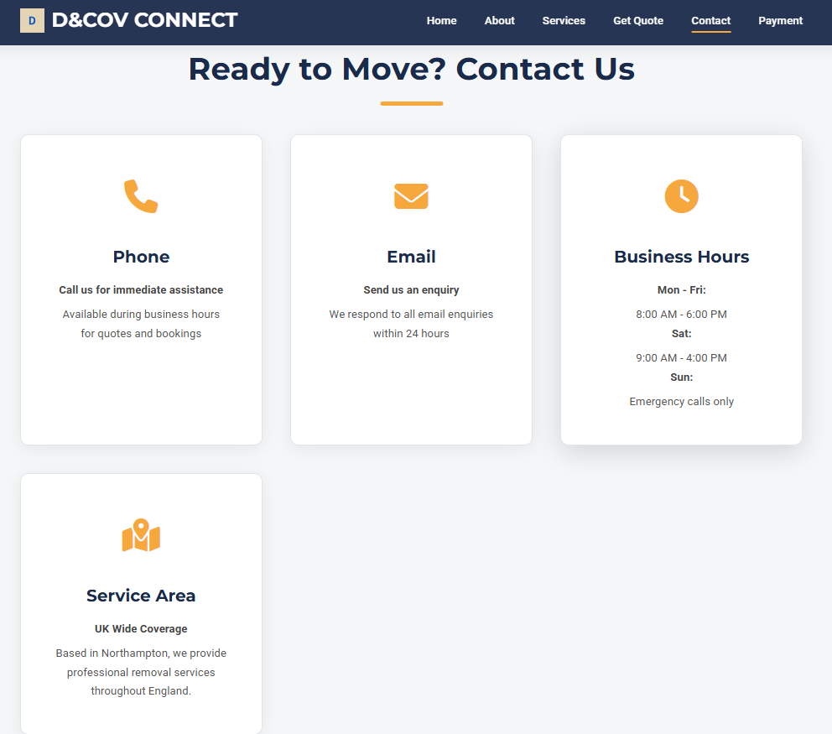

## **4.3 JavaScript: Interactivity**

Interactivity was incorporated with the aid of JavaScript. It consisted of simple form validation on the contact page, ensuring that inputs were entered correctly before submission. A responsive navbar toggle was also added to accommodate mobile navigation, making the navbar collapsible and expandable based on-screen width. Smooth scrolling and hover were incorporated for improved user experience. Although the site was largely static, JavaScript incorporation allowed interactivity where needed without overcomplicating things.

## **4.4 Workflow Steps**

The development process had a clear workflow:

* Plan: Set the content and navigation structure according to business requirements.
* Build: Create the homepage, services page, and contact page with semantic HTML.
* Style: Use Bootstrap for responsiveness, DaisyUI for styled components, and Shadcn/UI for contemporary UI elements.
* Integrate: Test all interactive elements, such as the contact form and navigation menu, on various devices and browsers.

This process ensured that every step progressed logically from the last, minimizing mistakes and making development efficient.

## **4.5 Deployment using GitHub Pages**

The last step of development was deployment. The site was deployed to a GitHub repository and hosted by GitHub Pages, which is a free and stable hosting option for static sites. This exposed the site to the public at [D&COV Connect](https://kool-cool.github.io/D_COV/).

Ensuring professional exposure without necessitating sophisticated server setups. Deployment via GitHub Pages also allowed versioning, so future updates and bug fixes could be handled with ease.

The development phase took preliminary requirements and converted them into a responsive, professional website following client branding and user expectations, setting the stage for testing and long-term upkeep.

# **5. Evaluation and Reflection**

## **5.1 Achievements**

The project was able to meet its main objective of providing a fully operational and responsive website for D&COV Connect Ltd within the four-week deadline. The website presents understandable and accessible information concerning the company's services so that prospective clients are able to easily find services like home removals, office relocation, packing, storage, and man & van services. One of the key successes was enhancing access to services by making information available in an organized and accessible manner. This is in line with contemporary web usability guidelines, where simplicity and ease of use are paramount in retaining visitors.

Before the site is created, there are unspoken rules on visibility. Being visible means that the enterprise should appear to make potential clients consider the company on their lists of professional alternatives. With its low-key character, its simplicity, use of unified brand elements, and responsive design, the new online presence now alludes to professional reliability, a preface necessary for any business engaged in services. This preparation will be used for future online marketing activities, such as search engine optimization and end-user interaction facilities.

## **5.2 Challenges Faced**

Although the originally planned activities were realized, they had numerous unforeseen challenges. Time management was critical, especially with coding, as it involved juggling numerous tasks simultaneously, including content organization, styling of elements, and interactivity. There were a few sneaky browser compatibility problems as well: CSS would have to be altered depending on the way styles rendered into Chrome, Edge, or Firefox. Finally, ensuring responsiveness for every single mobile device was a big challenge, as layouts needed to be fluid across every platform without compromising usability.

## **5.3 Challenge Solutions**

A combination of methods had to be applied to these. In time management, interviews were divided into daylong sprints for consistent development and to avoid procrastination at the eleventh hour. Compatibility issues were dealt with via the developer debugging tools, which permitted the rapid detection of inconsistencies and the application of fixes. Lastly, the iterative testing and feedback cycle was extremely important in establishing mobile responsiveness. Testing at every stage and incrementing progression conditioned the design to perform flawlessly on varied devices.

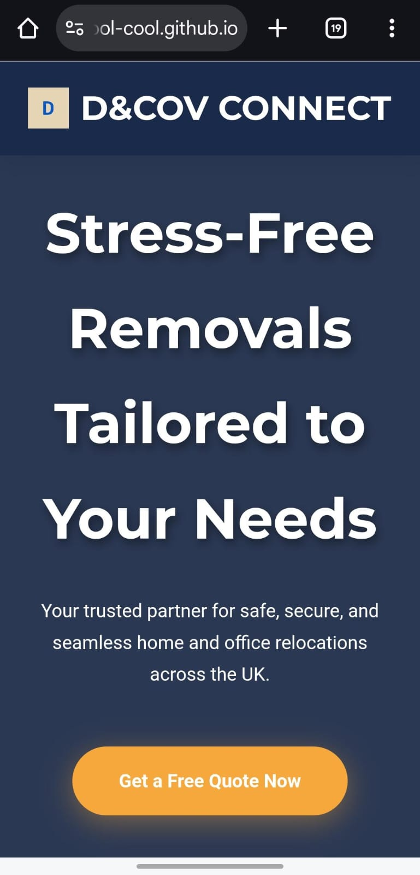

## **5.4 Future Development**

Since the website has already been created, a few refinements would add value, creating more functionality and interaction between the customer and the website. Future works would involve implementation of a live chat support system to assist customers instantly, and a much more improved booking system that empowers the customer to directly book their removals on the live website. A strong SEO formation would push the company's visibility higher and hence enable them to reach out to more clientele. Finally, the payment gateway implementation with multiple options would get the customers making payments online. This will give convenience and an edge to the service.

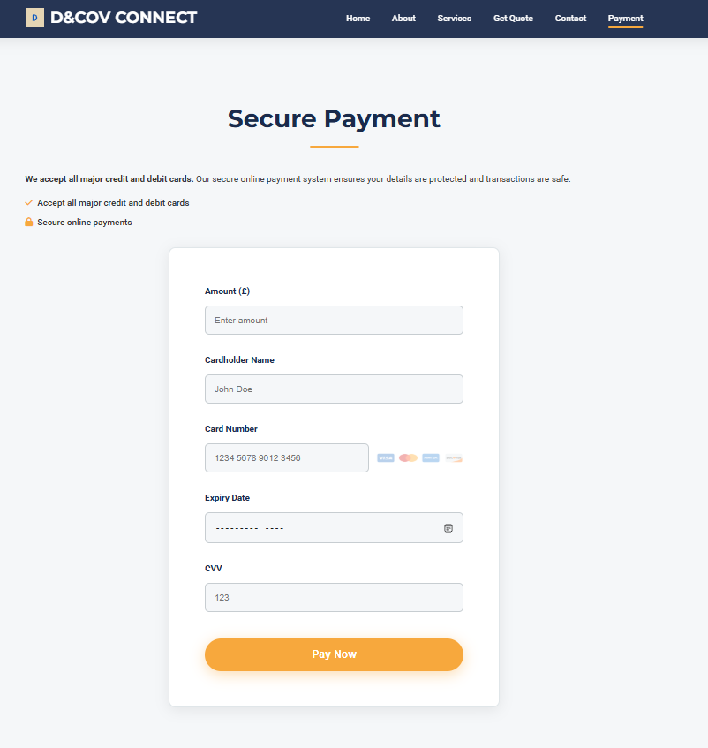

In summary, the project achieved its goals satisfactorily, and the future improvements outlined offer definite chances for expansion and long-term viability.

# **6. Conclusion:**

In the making of the D&COV Connect Ltd site, management, planning, and delivery of a professional digital solution were illustrated within the span of four weeks. By dint of being systematic design practices, responsive coding, and recursive testing, a platform in the service-enhancing domain was created to make services easy to find and access, provide professional branding, and build client confidence. Many issues were posed, and some successful problem-solving measures led to the triumph of the project. Features such as live chat, booking systems, and a full-blown SEO campaign can be put in place to provide extra enhancements to the environment of the website for guaranteeing future growth, competitiveness, and sustainability in an online market.

# **7. References:**

1. Chaffey, D. & Ellis-Chadwick, F. (2019) *Digital Marketing*. 7th edn. Harlow: Pearson.
2. Duckett, J. (2014) *HTML and CSS: Design and Build Websites*. Indianapolis: Wiley.
3. Laudon, K.C. & Traver, C.G. (2021) *E-commerce: Business, Technology, Society*. 16th edn. Harlow: Pearson.
4. Garrett, J.J. (2011) *The Elements of User Experience: User-Centered Design for the Web and Beyond*. 2nd edn. Berkeley: New Riders.
5. Krug, S. (2014) *Don’t Make Me Think, Revisited: A Common Sense Approach to Web Usability*. 3rd edn. San Francisco: New Riders.
6. Lock, D. (2020) *Project Management*. 11th edn. Abingdon: Routledge.
7. Nielsen, J. (2020) *Usability Engineering*. Burlington: Morgan Kaufmann.
8. Marcotte, E. (2014) *Responsive Web Design*. 2nd edn. New York: A Book Apart.
9. Morville, P. & Rosenfeld, L. (2015) *Information Architecture: For the Web and Beyond*. 4th edn. Sebastopol: O’Reilly Media.
10. Statista (2024) *Mobile internet traffic as share of total web traffic worldwide from 1st quarter 2015 to 1st quarter 2024*. <https://www.statista.com/statistics/277125/share-of-website-traffic-coming-from-mobile-devices/>